Welcome!
Here is your temporary Best Western Rewards® Membership Information
Your permanent card will be e-mailed within a few days after enrollment.
You can then download it on your mobile device.
More perks. More privileges.

Card Number: $y122 - $y123
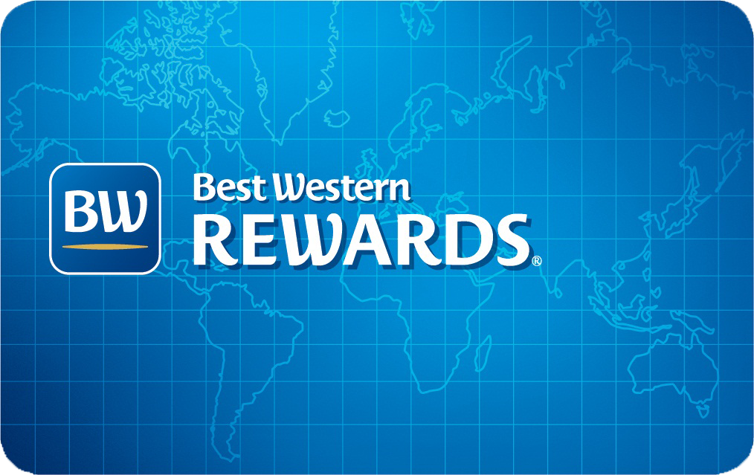

$Add1
$Add2
$Add3
$Add4
$Add5
$y124
$Add6
$Add7
$Add8
$Add9

Welcome to Best Western Rewards®!

As a new member of Best Western Rewards, you have many choices! You can earn 10 points for every U.S. dollar spent for stays at Best Western hotels or earn airline miles with your favorite airline. Simply add your Best Western Rewards membership number to your reservation and get rewarded for your stay.

Points can be redeemed for free nights, Best Western Travel Cards®, merchandise, car rentals and shopping gift cards – the list goes on and on. With redemption levels starting at just 1,400 points, you will be able to redeem your first award soon. You’ll get there even faster by taking advantage of our many promotions and our point-earning partners!

Manage your membership anytime, anywhere - online or by phone - 24 hours, 7 days a week.
- To access your online account, go to www.bestwestern.com
- Under My Profile at top of page, enter either your email address or your Best Western Rewards account number
- Enter your password and select sign-in

You can also access your account at any time by calling Customer Care at ++800 22 73 28 85
(from Europe, toll free).

Thank you for choosing Best Western International. We hope you will take advantage of the many benefits of being a Best Western Rewards member! We look forward to your next stay with us.

Sincerely,

Your Best Western Rewards Team

